**How to record volunteer hours and company match for Boeing company contributions**

**Go to**

<https://boeing.yourcause.com/auth>

Log in using your Boeing credentials

Once successfully logged in, hover over **“Volunteer”** at the top and click **“Search Opportunities”**



Once on the volunteer page, click **“All Organizations”**



Under **“Search by Organization Name”** input **“Bonney Lake Baseball Association”**

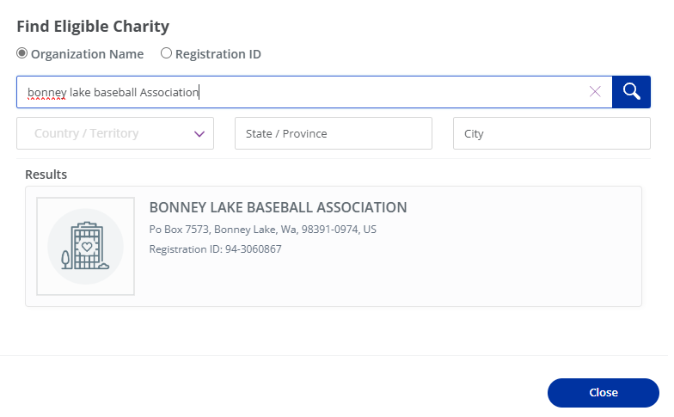

Select charity and add to your list

Once complete, under **“Volunteer”** at the top, select **“Record Hours”**

Select **“Add Hours / Edit”**

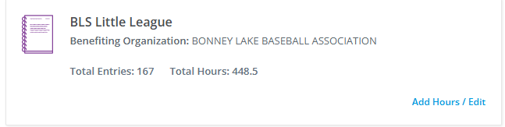

Fill out **“Participation Date”** and hours associated

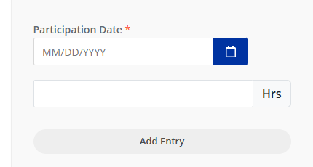

Scroll down and click **“Continue”** once all dates and hours have been input.

Review next page ad click **“Save”**

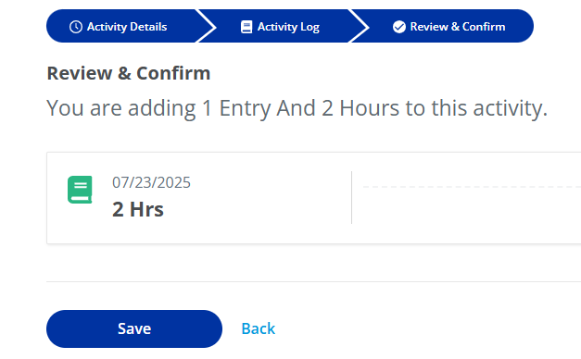

Once a minimum of 10 hours have been met, under **“My volunteering”** there will be a prompt that states **“Apply for a Volunteer Grant!”.** Click **“Apply Now”** and complete.   
  
Thank you for supporting BLS Little League!